Friends of hank aaron State Trail
  - Sponsorship Opportunities

19th Annual Hank Aaron State Trail 5K Run/Walk
Saturday, August 10, 2019

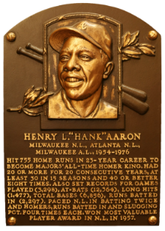 | 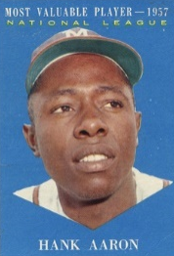 | 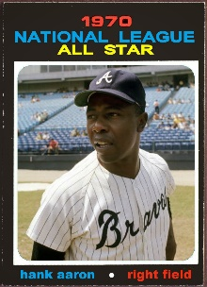
Hall of Fame  $5,000 | Most Valuable Player  $3,000 or in-kind equivalent | All Star  $1,500 or in-kind equivalent | Home Run King  $755 or in-kind equivalent | Championship Team  $250 or in-kind equivalent
Visual acknowledgment at a highly visible venue  Logo displayed in local advertising  Large logo on event t-shirt  Mention of sponsorship at event Start & Finish  Print & broadcast media acknowledgment  2+ social media posts including company name pre or post event  Large logo displayed on event signage  20 registrations in 5K run/walk with team logo on front of t-shirt  Logo & sponsorship recognition on website www.hankaaronstatetrail.org | Large logo on event t-shirt  Mention of sponsorship at event Start & Finish  Print & broadcast media acknowledgment  2+ social media posts including company name pre or post event  Large logo displayed on event signage  15 registrations in 5K run/walk with team logo on front of t-shirt  Logo & sponsorship recognition on website www.hankaaronstatetrail.org | Small logo on event t-shirt  Mention of sponsorship at event Start & Finish  Print & broadcast media acknowledgment  Social media post including company name pre or post event  Small logo displayed on day of event signage  10 registrations in 5K run/walk with team logo on front of t-shirt  Logo & sponsorship recognition on website www.hankaaronstatetrail.org | Print & broadcast media acknowledgment  Social media post including company name pre or post event  Business name displayed on day of event signage  5 registrations in 5K run/walk  Sponsorship recognition on website www.hankaaronstatetrail.org | Business name displayed on day of event signage  2 registrations in 5K run/walk  Sponsorship recognition on website www.hankaaronstatetrail.org

Jill Maertz | 414.840.1710 | fohast@gmail.com | HankAaronStateTrail.org

Friends of Hank Aaron State Trail is a 501(c)(3) non-profit organization

